**ADVANCED JAVA PROGRAMMING PROJECT**

UR Huye campus – Year 2 BIT

Group 3 Subgroup 11

**Names:** NSENGUMUREMYI Emmanuel

**Reg No:** 221008782

**Project Name:** Bus Management System

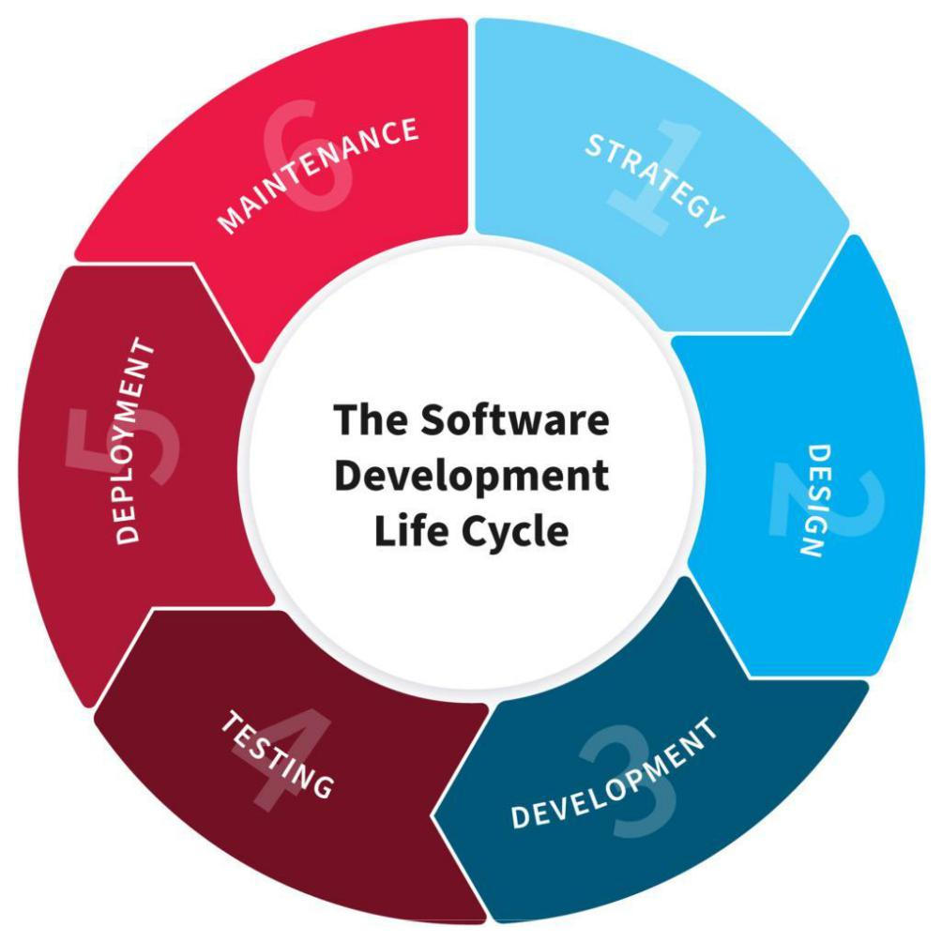

1. **Planning**

The **Bus Management System** this is a software application that aims to automate of the bus records and information management.

The software will provide complement centralized platform for administration to access and manage bus data such as passenger information, booked seats, bus directions and bus availability.

**The goals of the BMS (Bus Management System) are follows:**

* Automatically management of records and information of bus.
* Reducing duplicate of data that caused by manually system.
* Data accuracy improvement.
* Easy access of information.
* Quick and efficiency services.
* Decreasing the delay in services delivering.

**The objectives of the BMS (Bus Management System) are follows:**

* Development of system that allows administrator to input, store, manage and retrieve or view bus information.
* Providing a user-friendly graphic user interface for admin to access and manage bus data.
* To certify data security and confidentiality for bus records.
* To develop system that will provide better and quality service.
* Managing details of bus, tickets, booking and seats information.

**The problem this BMS (Bus Management System) need to solve are follows:**

* Inefficiency of manually system that are currently used.
* Duplication of data and errors.
* Hard to monitor the bus information and its movement to be improved.
* Hard in maintaining passenger details
* Insecurity of the bus information

The Bus Management System is the project that look forward the solutions that will achieves the goals and objectives that are listed upwards.

1. **Design**

**Technical requirements:**

* Our project developed as a java application using Apache NetBeans IDE.
* The project used MySQL workbench as the database management system to store and manage bus data.
* Other technical requirement is found in development and in deployment of the system.

**Functional requirement:**

* Security measurement for example (logins feature to authenticate the admins).
* The system will allow the searching of data.
* The system will allow the input, storing and viewing of bus information.
* The system will also include the report feature that will be helpful in monitoring bus data for improvement.
* System will allow access and management of records to the administration.

**User Interaction:**

* Admin will have full access to all bus information.
* Users have their user-friendly interface that will be helpful in navigation and in interaction of the system.
* The system has error handling in place to make sure data integrity and to guide the user through the process.

1. **Development**

Development of our project called “**Bus Management System**” in java using Apache NetBeans IDE and MySQL for database the details are follows:

**Database designing and setting up:**

We used MySQL as RDBMS (Relational Database Management System).

* We created database schema called bus management and tables that align with the functional requirement of the system.
* According to connectivity we used “MySQL-connector-java 5.1.23-bin.jar “driver.
* About creating tables, we used SQL scripts.
* Definition of relationships between tables are well created.

**About project development:**

* Opening of NetBeans IDE to create new java project for bus management system.
* Get on well the interfaces using java swings.
* Implementation of any good method that handle the insertion, manipulation and validation of data (source code).
* Holding on the communication between application and database.
* Making sure that if the data is being stored, viewed and updated correctly.

1. **Testing**

The bus management system project has test plan that follows:

* Safety should be tested (we tested the safety of our system).
* Displaying of interfaces was tested.
* Well notification delivering that align with functional requirement of our system was tested.
* Testing if the components of the system, such as the database and the user interface works correctly.
* Integration testing and testing whole system to make sure its meeting the functional and technical requirements.
* Fixing any defects or bugs that are identified during testing.
* Collecting feedbacks from users and use it to make improvement.

NB: Testing plan is done to verify that all the functionality that are integrated works correctly.

1. **Deployment**

The deployment phase is the final step in the software development life cycle and delivers the final product to the customer in a live production environment.

The Deployment Phase includes the work necessary to deploy the final solution into the target production environments.

Plus, creating guides for installation, system operations, system administration, and end-user functionality.

This phase it's involve in installation of system in various platform in order to know how it works on, and training end user to use your project.

For installing our project in devices platform there are some tools is required to install in computer such as:

* Java development kit(JDK)
* NetBeans platform
* MySQL-connector libraries,
* jCalendar libraries
* r2mxl libraries
* Xampp server
* MySQL databases

In conclusion , bus management system will facilitate users like; passengers

By reducing time and costs for enhancing digital system